1 - NUnit-Handson
Step 1: Creating a Unit test project and adding CalcLibrary as reference
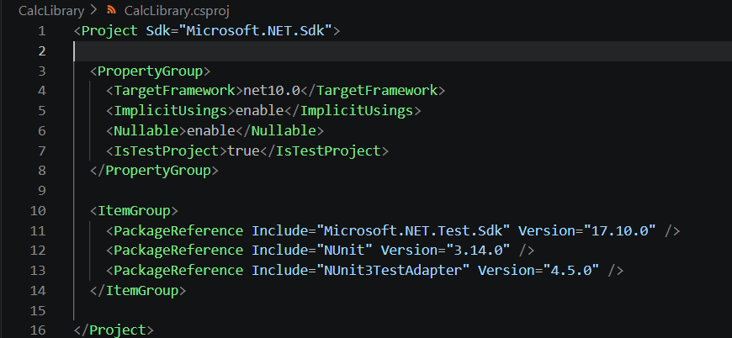
Step 2: Creating a class “CalculatorTests” to write all the test cases
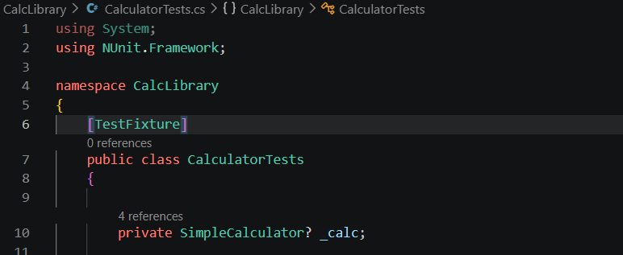
Step 3: Uses the ‘TestFixture’, ‘SetUp’ and ‘TearDown’ attributes
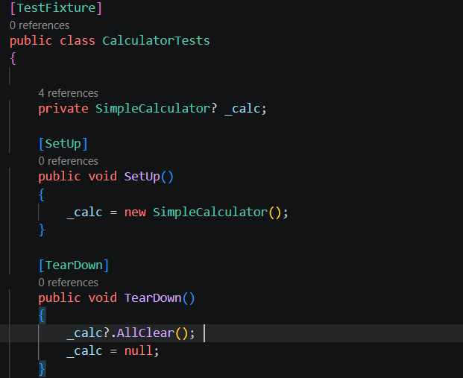
Steps 4, 5 & 6: Create a Test method for addition using ‘TestCase’ and Assert.That
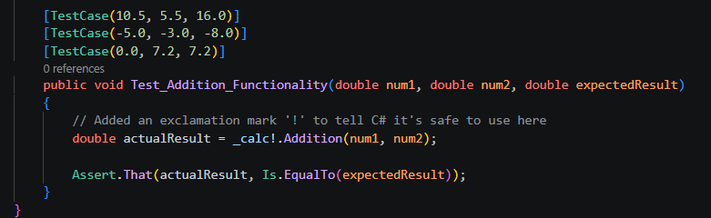
OUPUT:
